Art on the Coast 2024 Vendor Application

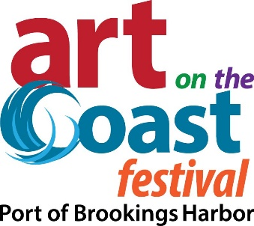
Set-up: Friday, Aug 2nd 3pm-8pm, Saturday 8am-9am

Take-down: Sunday, Aug 4th 5pm-8pm

Festival Hours: Saturday, Aug 3rd 10am-5pm Sunday, Aug 4th 10am-4pm

Costs: 12x12 $125, 12x24 $250, No charge for electrical

Applications must be received by May 1, 2024- mail early!

Make check payable & mail with application to:
Art on the Coast, PO Box 965, Brookings Or 97415

Early Bird Special: Post mark your application & payment by April 1st & you are placed in our Raffle drawing for a free booth space (up to $125 value). Drawing held at close of Festival. Must have set-up and been present both days to win.

Description: Art on the Coast Festival is a local volunteer effort to support the artistic community. Held at the Port of Brookings Harbor, the Festival offers vendors easy parking and offloading, level spaces and ample opportunity for great sales. The Port contains restaurants, motels, RV parks, restrooms and great access to Highway 101 and is always a favorite tourist spot.

Art on the Coast is a quasi-juried show with Artists being able to submit their application without photos if they have a website or social media page (Facebook, Etsy, Twitter etc.) with their current work or have participated in a local show or gallery in the last 3 years.

Artists will be notified if their entries are selected no later than May 1, 2024. Checks will not be cashed until applicant is accepted. Notifications sent via email so be sure to check your junk mail folders!!

This is a rain or shine event. No early take downs.

Questions? Email Laura Brown at artonthecoastbrookings@gmail.com, travelcurrycoast.com or call 720.320.0376.

Terms of Entry:
- Vendors may share a space with one other artist.
- Artists participating must be the actual creator or originator of the items in the booth.
- Retail, Buy-Sell vendors will NOT be considered.
- There is no overnight camping at the Port parking lots.
- Artists provide own tent, display furniture and handcart. We may experience coastal fog and drip; bring something to cover your art.
- All art/belongings must be inside your tent at night, covered and secured. Zippered tent sides are recommended!
- Vendor booths will be on asphalt or dock board; therefore, all tents must be weighted. Tents cannot be tied down to the railing or staked/screwed to the dock board. There can be wind in the afternoon at the Port therefore a properly weighted tent is required. Tent weights strapped to each leg or heavy weights that slide over each leg are great options. 40lbs per leg is a great rule of thumb at any outdoor venue. Weights for sale at https://www.uline.com/H-8015/Canopy-Weights or make your own.
- Overnight security is provided on Friday and Saturday nights however, Art on the Coast cannot guarantee your booth will be free from theft or damage. Artists should obtain business insurance for the event. Art on the Coast, Port of Brookings Harbor its agents, officers, employees and volunteers will not be responsible for any theft, damage, loss or claim whatsoever arising from any cause, nor incurred by reason of failure of the exhibitor to obtain insurance or failure of such insurance to cover.
- No pets allowed in your booth (service dogs are excepted).
- No refunds after May 1st for any reason. In case Art on the Coast is cancelled, a full refund will be issued.
- Vendors agree to assume ALL risk during their participation and hold harmless Art on the Coast and the Port of Brookings Harbor its agents, officers, employees and volunteers from any actions, suits, damages, claims, third-party claims or judgements of any kind that may result from property loss, damage or personal injury sustained by vendor or anyone else as a result of negligence during vendor’s participation. By submitting your application, you agree to all of the above.

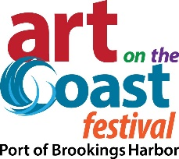
Application

Name (last, first) ______________________________________________________________

Business Name________________________________________________________________

Mailing Address ______________________________________________________________

Need 20amp Electrical? Y / N

Email _______________________________________________________________________

Daytime/Cell Phone ___________________________________________________________

Website URL/ Social Media Site Address

____________________________________________________________________________

No website or social media site? Where are you/have shown your work in the last 3 years? Provide name & location.

Medium __________________________________________________ (Woodworker, Silversmith, Bead Jewelry, Watercolor, Oils, Photography, Fabric, Collage, Ceramics, Sculpture, Mixed Media, Glass, Paper, Mosaics, Essential Oils/Soap, Tasty Treats, Other?

SPECIAL REQUEST: _________________________________________________________

Signed:

Date:

PRINT NEATLY PLEASE!
